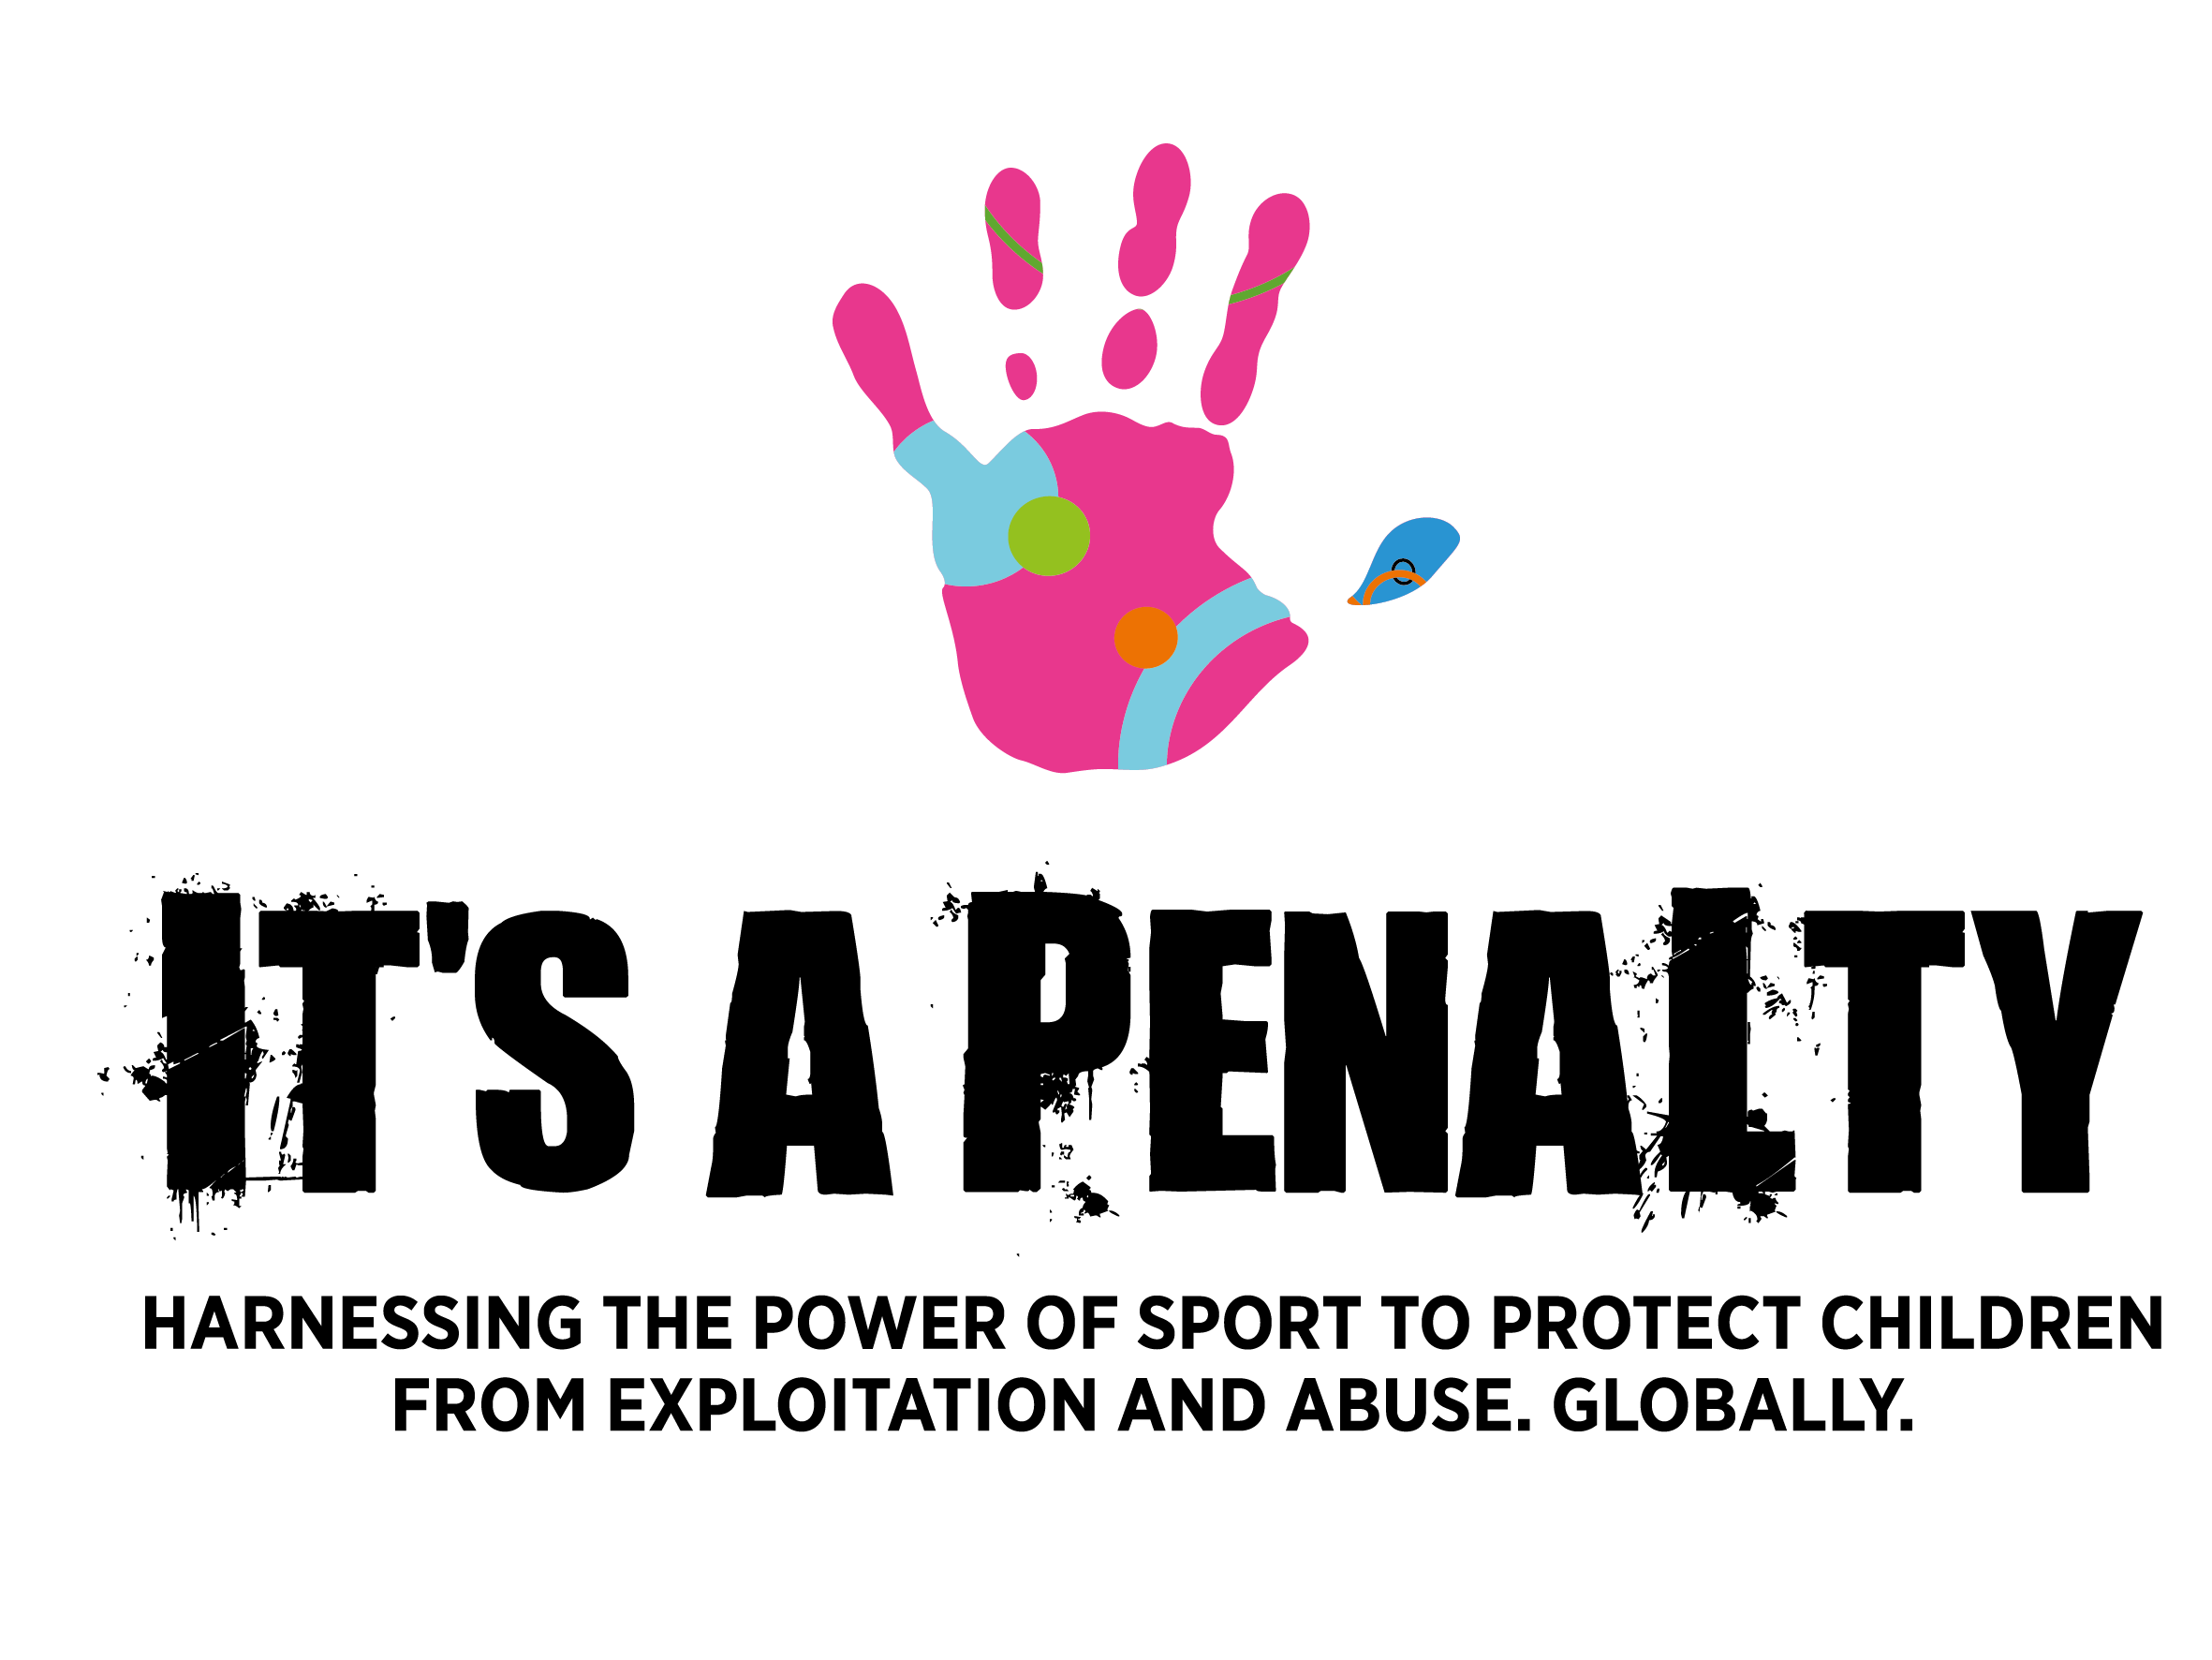

**Sarah De Carvalho MBE**

After graduating from the University of Surrey with an MBA and spending almost ten years as a publicist and producer for the likes of BBC Television, Village Roadshow and Sky, Sarah de Carvalho left the media industry in 1991 to join a missionary organisation in Brazil. There she met children from the age of seven living on the streets, taking drugs, stealing to survive and vulnerable to prostitution and gang warfare.

The experience had a massive impact and she ended up living in a favela to identify better with those children and in 1993, founded the charity *Happy Child International*, dedicated to providing physical, educational and spiritual care for street children in the Belo Horizonte area of Brazil. The charity began with a 24-hour shelter and has now expanded to 11 centres with 70 staff able to work with 150 children at any one time. *Happy Child* has rescued over 11,500 street children in the cities of Belo Horizonte and Recife in Brazil.

Since 2006, Sarah has been living in England with her husband and three children, continuing her work in growing *Happy Child* and becoming a leading campaigner for street children. She has written two books on the subject - *The Street Children of Brazil* and *Solomon’s Song*. In 2012, Sarah was awarded an MBE for her services to *Happy Child*.

Sarah then experienced another moment that would change the course of her life once again – she met Rose.

Sarah met Rose late at night outside a motel in north east Brazil, with a group of other very young girls dressed up to look older than they were. Rose told Sarah that she was 11 years old when her mother sent her to the streets to beg for money because there was no food at home. Rose, like other street children, was vulnerable to exploitative people who use these children to make money and by the age of 16, she had given birth to two babies.

When Rose looked Sarah in the eye and said, ‘Please do something to help us”, Sarah decided to act.

Sarah set up a new charity to take the work she had developed over the last 20 years to a global level. The [*It’s A Penalty*](http://www.itsapenalty.org) campaign aims to protect vulnerable children from exploitation, abuse and trafficking around major global sporting events worldwide.

Having so far completed two campaigns around the 2014 World Cup and 2016 Rio Olympics & Paralympics in Brazil, It’s a Penalty, together with their partners, has facilitated the protection and rescue of over 16,300 victims of child sexual exploitation, and prevented thousands more children from becoming victims.

Since the launch, the It’s a Penalty campaign has reached and impacted a total of 519 million people worldwide, enabling it to play a part in building a better and safer world for children before, during, and after these major sporting events.

Future campaigns are Super Bowl LIII Atlanta 2019; Hong Kong Rugby Sevens 2019; Tokyo Olympics & Paralympics 2020; UEFA European Football Championships 2020; ICC Champions Trophy India 2021; Beijing Winter Olympics & Paralympics 2022; Commonwealth Games Birmingham UK 2022; Qatar Football World Cup 2022.

**Below is an interview from 2013 where Sarah explains how witnessing horrific violence toward children in Brazil made her feel that she had to do something.**

**“Children were not children anymore.”**

<https://www.youtube.com/watch?v=ge-BQU12dbw>