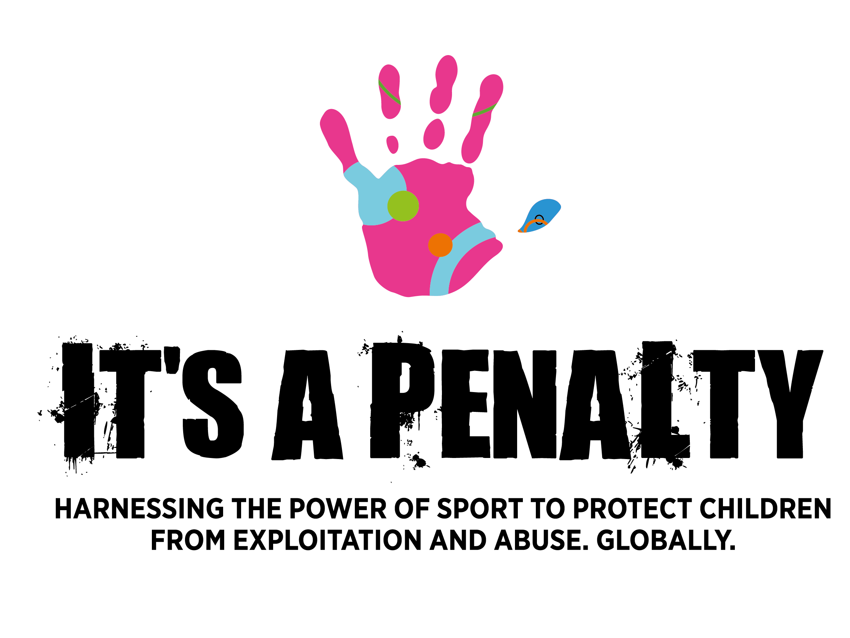

**It’s a Penalty backgrounder:**

**What is It’s a Penalty?**

The It’s a Penalty campaign harnesses the power of sport to protect children from abuse, exploitation and trafficking globally, positioning major sporting events as platforms for positive change.

In order to have greater reach and impact in protecting children from harm, It’s a Penalty works in association with all those involved in major sporting events – including international airlines; the biggest names in sport; hotels; sporting governing bodies; international and local NGOs; corporates and law enforcement agencies – to use the events as a springboard to **EDUCATE** the public about the global issues of child abuse, exploitation and trafficking, including the penalties for offenders; **ENCOURAGE** everyone that ‘**IF YOU SEE SOMETHING SAY SOMETHING**’; and

**EQUIP** people with the mechanisms to both identity and report these crimes globally.

Alongside campaigning work around major sporting events, It’s a Penalty is also advocating for the global enactment and implementation of extra-territorial legislation against child exploitation, which will allow countries to prosecute their citizens for the abuse of children if the offence takes place abroad. Currently, only 43 out of the 205 National Olympic Committees worldwide have such provisions in place, amounting to a mere 21%.

The **ultimate goal** of the campaign is to eradicate child abuse, exploitation and trafficking by 2030, contributing to the achievement of the UN Sustainable Development Goals target 16.2, ‘to end abuse, exploitation, trafficking, torture and all forms of violence against children.’

**How did It’s a Penalty come about?**

The first It’s a Penalty campaign was launched ahead of the 2014 World Cup in Brazil, to prevent the exploitation and abuse of children on the ground in Brazil. The high influx of visitors and tourists to the country for the duration of the event meant that vulnerable children and adolescents would be placed even more at risk of exploitation or abuse. The original It’s a Penalty campaign took place following the introduction of extra-territorial UK government legislation enabling prosecution of sex offenders both abroad and in their home countries. The huge success of this activity for the World Cup led to It’s a Penalty working with the IOC and introducing an even more extensive campaign around the 2016 Rio Olympics and Paralympics.

**What’s the issue?**

Each year:

* Over 2 million children are exploited into the global sex trade (UNICEF)
* 1.2 million children are involved in human trafficking (UNICEF)
* Almost 20% of trafficking victims are children (UNICEF)
* 63% of child sex trafficking survivors were advertised online at some point during their trafficking situation (Thorn)
* 40 million children worldwide experience some form of abuse each year (WHO)

**Why target major sporting events?**

Sport has a tremendous power to unite and break cultural barriers. Major sporting events allow a spotlight to be shone on the issues by bringing people together from across the globe and allowing the campaign to have maximum impact.

The massive influx of visitors whilst a sporting event takes place also greatly increases the risk for vulnerable children. Research by the University of Dundee clearly identifies that the demand for children and women in the sex trade increases when a global sporting event is taking place (University of Dundee, 2014).

**How does It’s a Penalty create change?**

It’s a Penalty believes that we all have a part to play in building a safer world for children, and that prevention is better than cure. It is a call to action and an invitation to the global audience to understand how children are abused, exploited and trafficked and join the fight against these crimes.

**What are the campaign’s main objectives?**

* **EDUCATE** the general public about the issues of child abuse, exploitation and trafficking, including the penalties for offenders
* **ENCOURAGE** sporting fans, tourists, local residents and the general public that ‘**IF YOU SEE SOMETHING SAY SOMETHING**’
* **EQUIP** people with ways to both identity and report these crimes globally

**Which events will be a focus in 2018?**

**2018 is the biggest year to date, with four major global sporting events being targeted:**

* Super Bowl LII in Minneapolis, USA – 4 February 2018
* Winter Olympics & Paralympics in South Korea – 9-25 Feb 2018
* Commonwealth Games at Gold Coast, Australia – 4-15 Apr 2018
* Rugby Sevens in Hong Kong – 6-8 April 2018

**What has It’s a Penalty achieved so far?**

It’s a Penalty has achieved major success across both its campaigns to date, illustrated by the following statistics:

* It’s a Penalty campaign messages have reached a total of 519 million people across the two campaigns
* The campaign film has been shown on 9 international airlines and been seen in-flight by over 40 million passengers
* Every football fan travelling from the UK to Brazil for the World Cup received an It’s a Penalty wristband from The FA
* Over 70,000 football fans and tourists around stadiums in Brazil received leaflets informing them about the Brazilian Child Protection Helpline
* Over 11,000 calls were made during the 2014 World Cup reporting cases of crimes against children
* 87 arrests were made during the World Cup of foreign nationals engaging in child abuse or exploitation
* In comparison, during the 2016 Olympics, there were no arrests of foreign offenders
* There were no incidents in Olympic venues of crimes against children or adolescents

**Who’s behind It’s a Penalty?**

Sarah de Carvalho MBE is the CEO of the campaign supported by other trustees including Christianne Williamson, Ewen McAlpine, Katherine Penelope Corich, Jackie Brock-Doyle OBE, Geoff McDonald and Colin McLellan.

The campaign partners are Comic Relief and The A21 Campaign and it is run in association with The McCain Institute.

**Ambassadors of the 2018 campaign are:**

* Liam Malone – Paralympic Champion
* Cathy Freeman – Olympic Champion
* Tanni Grey-Thompson – Paralympic Champion
* Usain Bolt – Olympic Champion
* David Luiz – International Football Player
* Gary Lineker – Former International Football Player, BBC Presenter
* Francois Pienaar – Former International Rugby Union Player
* Rashad Jennings – NFL Player
* Jerome Flynn – Game of Thrones Actor – WV Ambassador
* Maro Itoje – Saracens & International Rugby Player

**Social channels:**

* Twitter: @its_apenalty
* Facebook: FB.com/itsapenaltycampaign
* Instagram: @its_apenalty

**Campaign hashtags:**

* Hero: #itsapenalty
* Supporting: #knowthesigns ; #togetherwecan

**2018 Campaign Activities and Dates for the Diary:**

* On January 24th, 2018, the It’s a Penalty campaign will be launched worldwide
* To mark the launch, a 30-second film – featuring Usain Bolt, Rashad Jennings, Cathy Freeman, Maro Itoje, Liam Malone, David Luiz and Jerome Flynn – will be shown in-flight by the following AIRLINES from February to April: American Airlines, British Airways, TAM, Ethiopian, Virgin Australia, Cathay Pacific, Cathay Dragon. If you are flying on any of these airlines during this period, please watch the film – take a picture and post on social media with #ITSAPENALTY
* The campaign film will be shown at many venues throughout the world
* The campaign has created a WORLD MAP for people to learn the reporting mechanisms wherever they are in the world
* In addition, people will also be able to access the map via the Campaign’s SAFEGUARDING APP – this APP will connect people to global reporting mechanisms to keep children safe
* Informative materials will be distributed in the four countries hosting the major sporting events

For more information, media enquiries or for an interview request, please contact:

Becky Fairlie-Clarke, Damy McConnell, Chris McKeown

T: +44 7974 306 579 / 020 3696 5730

E: [becky@trinorth.co.uk](mailto:becky@trinorth.co.uk) [damy@trinorth.co.uk](mailto:damy@trinorth.co.uk) [chris@trinorth.co.uk](mailto:chris@trinorth.co.uk)